**CH2 Global E-business and Collaboration**

學習目標 :

* 1. 什麼是企業流程？ 它們與資訊系統有什麼關係？
  2. 系統如何為企業中的不同管理團隊提供服務？連接企業的系統

如何改善組織績效？

* 1. 為什麼協作(collaboration)和社會型企業(social business)的系統如

此重要，他們使用了什麼科技？

* 1. 資訊系統功能在企業中的作用是什麼？
* Enterprise Social Networking Helps ABB Innovate and Grow
* Problem : ABB had a corporate intranet, but management

believed it was too static and outmoded to meet its current needs for empowering and energizing employees.

* Solution : ABB replaced its outmoded intranet with one called Inside+ that is more dynamic and socially enabled.

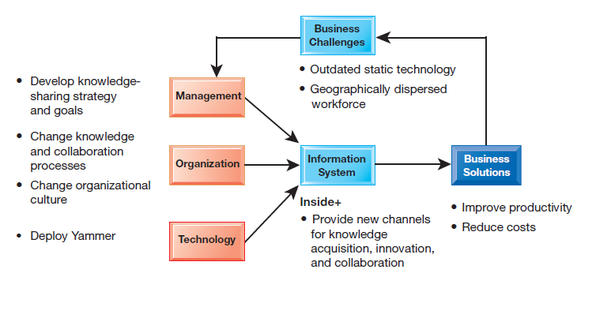

1. BUSINESS PROCESSES AND INFORMATION SYSTEMS
   * BUSINESS PROCESSES

* Businesses
* Can be seen as collection of business processes
* Business processes
* the manner in which work is organized, coordinated, and focused to produce a valuable product or service.
* the collection of activities required to produce a product or service
* supported by flows of material, information, and knowledge among the participants in business processes.
* the unique ways in which organizations coordinate work, information, and knowledge, and the ways in which management chooses to coordinate work.
* To a large extent, the performance of a business firm depends on how well its business processes are designed and coordinated
* Many business processes are tied to a specific functional area.
* 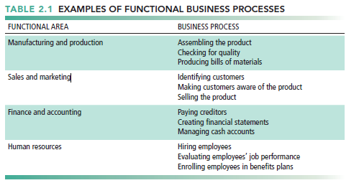
* Other business processes cross many different functional areas and require coordination across departments
* 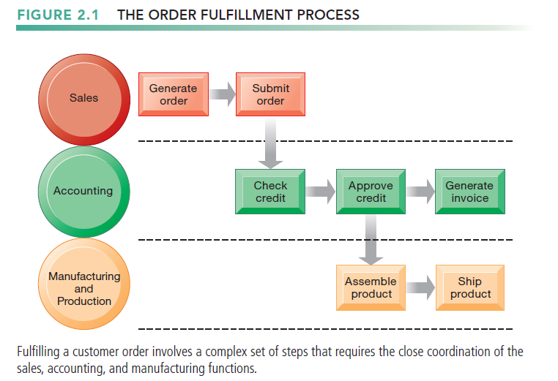
  + How Information Technology Improves Business Processes
* Increasing efficiency of existing processes
* Automating steps that were manual
* Enabling entirely new processes
* change the flow of information, making it possible for many more people to access and share information.
* replacing sequential steps with tasks that can be performed simultaneously
* eliminating delays in decision making.
* changes the way a business works and supports entirely new business models

1. TYPES OF INFORMATION SYSTEMS
   * Preface

* Replaced with large-scale cross-functional systems that integrate the activities of related business processes and organizational units.
  + Systems for Different Management Groups
* Transaction Processing Systems (TPS)
* Serve operational managers and staff
* Perform and record daily routine transactions necessary to conduct business
* Examples: sales order entry, payroll, shipping
* At the operational level, tasks, resources, and goals are predefined and highly structured
* The decision to grant credit to a customer, for instance, is made by a lower-level supervisor according to predefined criteria.
* Allow managers to monitor status of operations and relations with external environment
* Example : a TPS for payroll processing
  + - TPS are also major producers of information for the other systems and business functions.

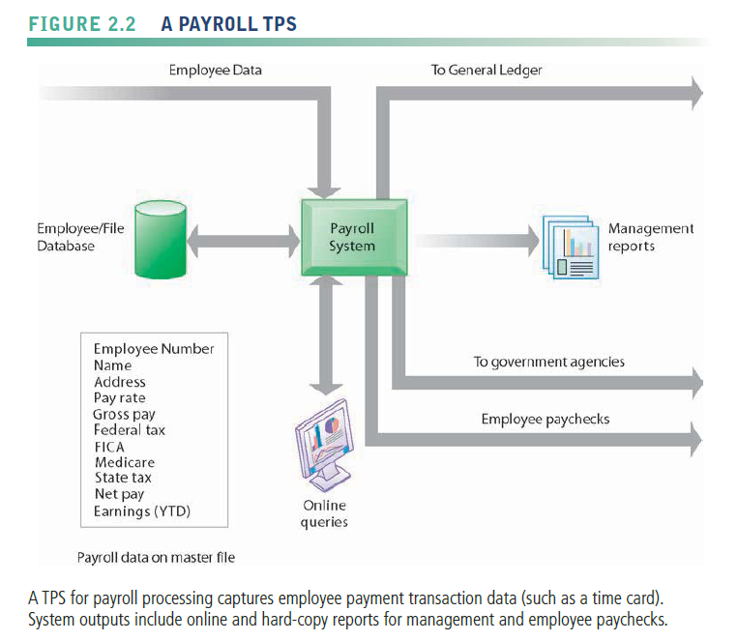

* Systems for Business Intelligence
* focus on delivering information to support management decision making.
* Business intelligence
  + - Data and software tools for organizing and analyzing data
    - Used to help managers and users make improved decisions
    - addresses the decision-making needs of all levels of management
* Business intelligence systems
* Management information systems(與第一章定義的MIS有些不同須注意)
* Decision support systems
* Executive support systems
* management information systems (MIS)
  + - also designates a specific category of information systems serving middle management.
    - provide middle managers with reports on the organization’s current performance
    - monitor and control the business and predict future performance
    - summarize and report on the company’s basic operations using data supplied by transaction processing systems.

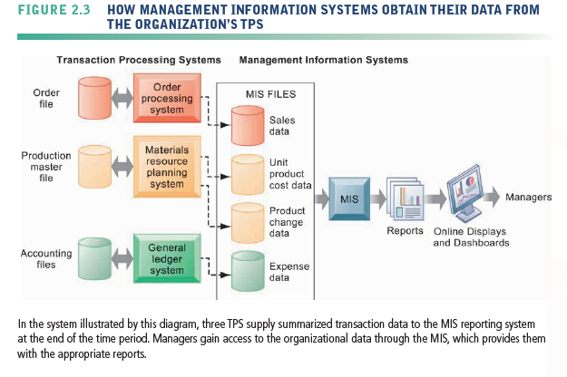

* + - Generally not flexible and have little analytical capability
    - typically provide answers to routine questions that have been specified in advance and have a predefined procedure for answering them.

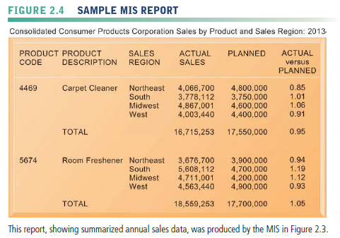

* + - Most MIS use simple routines, such as summaries and comparisons
* Decision-support systems (DSS)
  + - focus on problems that are unique and rapidly changing, for which the procedure for arriving at a solution may not be fully predefined in advance
    - use internal information from TPS and MIS, they often bring in information from external sources
    - employed by “super-user” managers and business analysts who want to use sophisticated analytics and models to analyze data.
    - Model driven DSS : Voyage-estimating systems

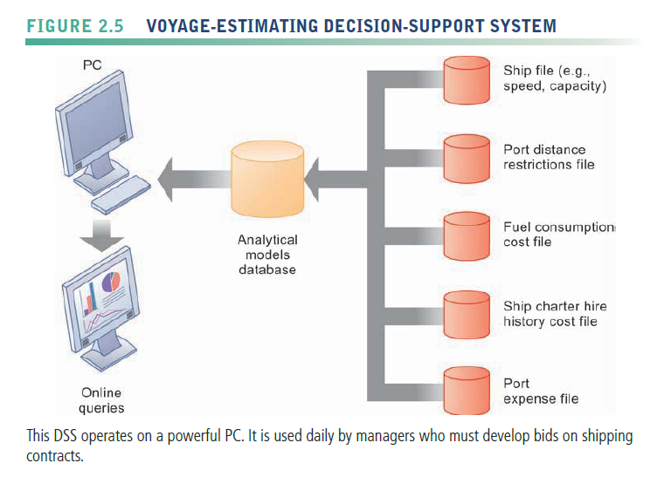

* + - Data driven DSS : Intrawest’s marketing analysis systems
* Executive support systems (ESS)
  + - help senior management focus on strategic issues and long-term trends, both in the firm and in the external environment
    - Address nonroutine decision making.
    - Incorporate data about external events (e.g., new tax laws or competitors) as well as summarized information from internal MIS and DSS
    - filter, compress, and track critical data, displaying the data of greatest importance to senior managers
    - Typically use portal with Web interface, or digital dashboard, to present content
    - Example: Digital dashboard with real-time view of firm’s financial performance: working capital, accounts receivable, accounts payable, cash flow, and inventory

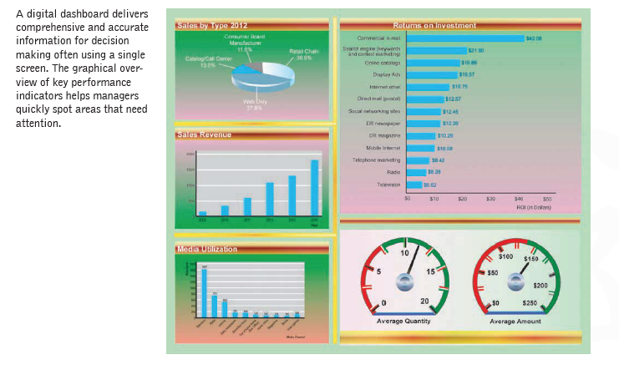

* + SYSTEMS FOR LINKING THE ENTERPRISE
* Enterprise Applications
* Systems for linking the enterprise
* span functional areas, focus on executing business processes across the firm and include all levels of management.
* help businesses become more flexible and productive by coordinating their business processes more closely and integrating groups of processes.
* Four major types:
  + - 1. Enterprise systems (enterprise resource planning (ERP))
    - integrate business processes in manufacturing and production, finance and accounting, sales and marketing, and human resources into a single software system
    - Resolves problem of fragmented data
    - Coordination of daily activities
    - Efficient response to customer orders (production, inventory)
    - Help managers make decisions about daily operations and longer-term planning
      1. Supply chain management systems
    - Manage firm’s relationships with suppliers
    - share information about orders, production, inventory levels, and delivery of products and services.
    - Goal : Right amount of products to destination with least amount of time and lowest cost.
    - lowering the costs of moving and making products and by enabling managers to make better decisions about how to organize and schedule sourcing, production, and distribution.
    - one type of interorganizational system because they automate the flow of information across organizational boundaries.
      1. Customer relationship management systems(CRM)
    - Help manage relationship with customers.
    - Provide information to coordinate business processes that deal with customers in sales, marketing, and customer service
    - Helps firms identify, attract, and retain most profitable customers
      1. Knowledge management systems(KMS)
    - Support processes for capturing and applying knowledge and expertise
    - Collect relevant knowledge and make it available to improve business processes and management decisions.
    - Link firm to external sources of knowledge.

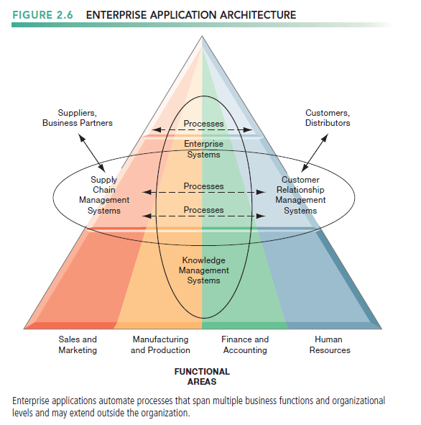

* Intranets
* simply internal company Web sites that are accessible only by employee.
* an internal network
* they often are simply a private access area in a larger company Web site
* Extranets
* accessible to authorized vendors and suppliers, and are often used to coordinate the movement of supplies to the firm’s production apparatus.
* Often used to coordinate supply chain
  + E-business, E-commerce, and E-government
* E-business
* use of digital technology and the Internet to execute the major business processes in the enterprise
* includes activities for the internal management of the firm and for coordination with suppliers and other business partners
* E-commerce
* Subset of e-business
* deals with the buying and selling of goods and services over the Internet
* E-government
* Using Internet technology to deliver information and services to citizens, employees, and businesses
* makes government operations more efficient and also empowers citizens by giving them easier access to information and the ability to network electronically with other citizens

1. SYSTEMS FOR COLLABORATION AND SOCIAL BUSINESS
   * What Is Collaboration?

* Collaboration
* working with others to achieve shared and explicit goals.
* focuses on task or mission accomplishment and usually takes place in a business, or other organization, and between businesses
* Short lived or long term
* Informal or formal (teams)
* one-to-one or many-to-many.
* Growing importance of collaboration:
* Changing nature(性質) of work
  + - jobs require much closer coordination and interaction among the parties involved in producing the service or product
* Growth of professional work
  + - “Interaction” jobs tend to be professional jobs in the service sector that require close
* Changing organization of the firm
  + - work is organized into groups and teams, and the members are expected to develop their own methods for accomplishing the task
* Changing scope of the firm
  + - The work of the firm has changed from a single location to multiple locations—offices or factories throughout a region, a nation, or even around the globe
* Emphasis on innovation
  + - Strong collaborative practices and technologies are believed to increase the rate and quality of innovation
* Changing culture of work and business
  + - Popular notions of the crowd (“crowdsourcing,” and the “wisdom of crowds”) also provide cultural support for collaboration and teamwork.
  + What Is Social Business?
* social business
* Use of social networking platforms to engage employees, customers, suppliers
* Goal is to deepen interactions with groups inside and outside the firm to expedite and enhance information sharing, innovation, and decision making.
* key word : conversations
* Requires information transparency
  + - drive operational efficiencies, spur innovation, and accelerate decision making

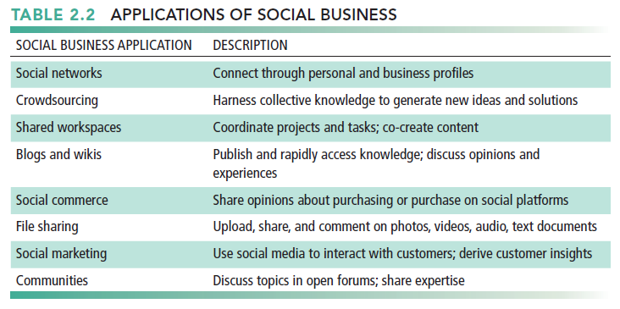

* + Business Benefits of Collaboration and Social Business
* Investment in collaboration technology can return large rewards, especially in sales and marketing, research and development
* Benefits
* Productivity
* Quality
* Innovation
* Customer service
* Financial performance

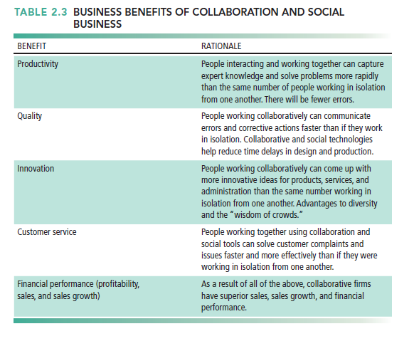

* how collaboration is believed to affect business performance.

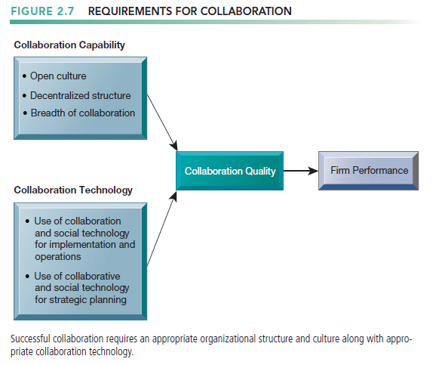

* + Building a Collaborative Culture and Business Processes
* Collaboration won’t take place spontaneously in a business firm, especially if there is no supportive culture or business processes
* “Command and control” organizations
* No value placed on teamwork or lower-level participation in decisions
* Collaborative business culture
* Senior managers are responsible for achieving results, but rely on teams of employees to achieve and implement the results.
* Policies, products, designs processes, and systems are much more dependent on teams at all levels of the organization to devise, to create, and to build.
* The function of middle managers is to build the teams, coordinate their work, and monitor their performance
  + Tools and Technologies for Collaboration and Social Business
* Preface
* A collaborative, team-oriented culture won’t produce benefits without information systems in place to enable collaboration and social business.
* E-mail and Instant Messaging (IM)
* Major communication and collaboration tools for interaction jobs
* sharing files as well as transmitting messages
* instant messaging systems allow users to engage in real-time conversations with multiple participants simultaneously
* In recent years, e-mail use has declined, with messaging and social media becoming preferred channels of communication.
* Wikis
* a type of Web site that makes it easy for users to contribute and edit text content and graphics without any knowledge of Web page development or programming techniques
* For storing and sharing corporate knowledge and insights.
* Virtual worlds
* Real-world people represented by avatars meet, interact, and exchange ideas at these virtual locations using gestures, chat box conversations, and voice communication
* Collaboration and social business environments
* Virtual Meeting Systems (telepresence)
* Cloud collaboration services (Google Tools, cyberlockers)

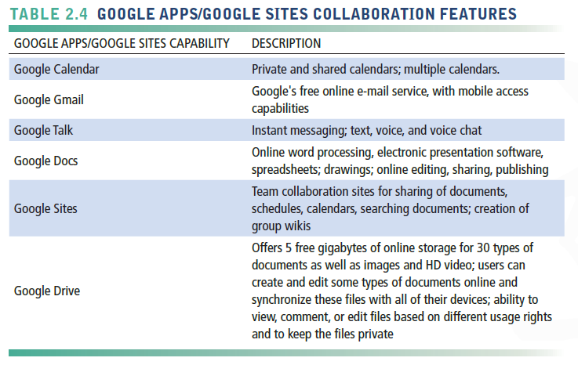

* Microsoft SharePoint
* IBM Notes
* Enterprise social networking tools

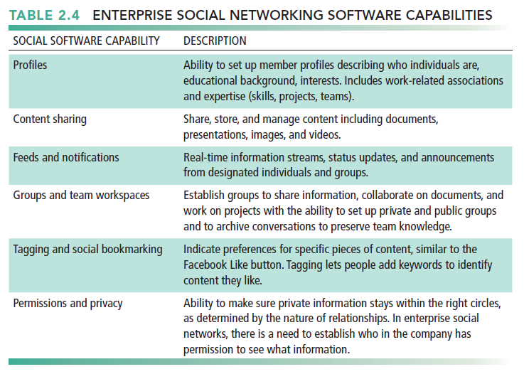

* Checklist for Managers: Evaluating and Selecting Collaboration and Social Software Tools
* Two dimensions of collaboration technologies

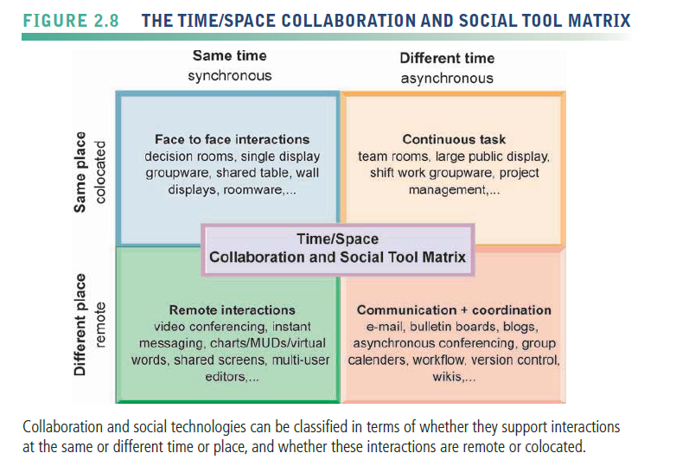

* + - Space (or location)—remote or co-located
    - Time—synchronous or asynchronous
* Six steps in evaluating software tools

1. What are your firm’s collaboration challenges?
2. What kinds of solutions are available?
3. Analyze available products’ cost and benefits.
4. Evaluate security risks.
5. Consult users for implementation and training issues.
6. Evaluate product vendors.
7. THE INFORMATION SYSTEMS FUNCTION IN BUSINESS
   * Information systems department

* the formal organizational unit responsible for information technology services
* responsible for maintaining the hardware, software, data storage, and networks that comprise the firm’s IT infrastructure.
* consists of specialists
* Programmers
  + - highly trained technical specialists who write the software instructions for computers
* Systems analysts
  + - constitute the principal liaisons between the information systems groups and the rest of the organization. It is the systems analyst’s job to translate business problems and requirements into information requirements and systems
* Information systems managers
  + - leaders of teams of programmers and analysts, project managers, physical facility managers, telecommunications managers, or database specialists
    - managers of computer operations and data entry staff.
* Chief information officer (CIO)
  + - a senior manager who oversees the use of information technology in the firm.
    - have a strong business background as well as information systems expertise
* Chief security officer (CSO)
  + - in charge of information systems security for the firm and is responsible for enforcing the firm’s information security policy
    - responsible for educating and training users and information systems specialists about security, keeping management aware of security threats and breakdowns, and maintaining the tools and policies chosen to implement security.
* Chief privacy officer (CPO)
  + - responsible for ensuring that the company complies with existing data privacy laws
* Chief knowledge officer (CKO)
  + - responsible for the firm’s knowledge management program
    - helps design programs and systems to find new sources of knowledge or to make better use of existing knowledge in organizational and management processes.
* Chief data officer (CDO)
  + - responsible for enterprise-wide governance and utilization of information to maximize the value the organization can realize from its data
    - collecting the appropriate data to serve its needs, deploying appropriate technologies for analyzing the data, and using the results to support business decisions
* End users
  + - representatives of departments outside of the information systems group for whom applications are developed
  + Organizing the Information Systems Function
* IT Governance
* organization
* Decision rights
* Accountability
* Organization of information systems function
  + - Centralized, decentralized, and so on